# **Web API and Kafka Hands-On Lab**

# **Document 1 Swagger and Web API Setup**

ValuesController code :

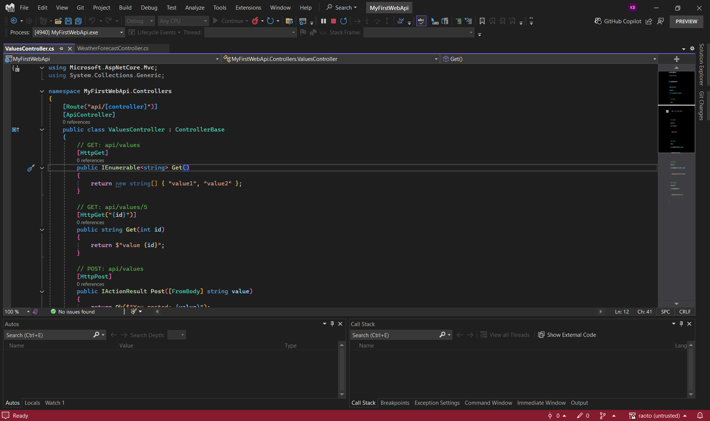

Program.cs code:

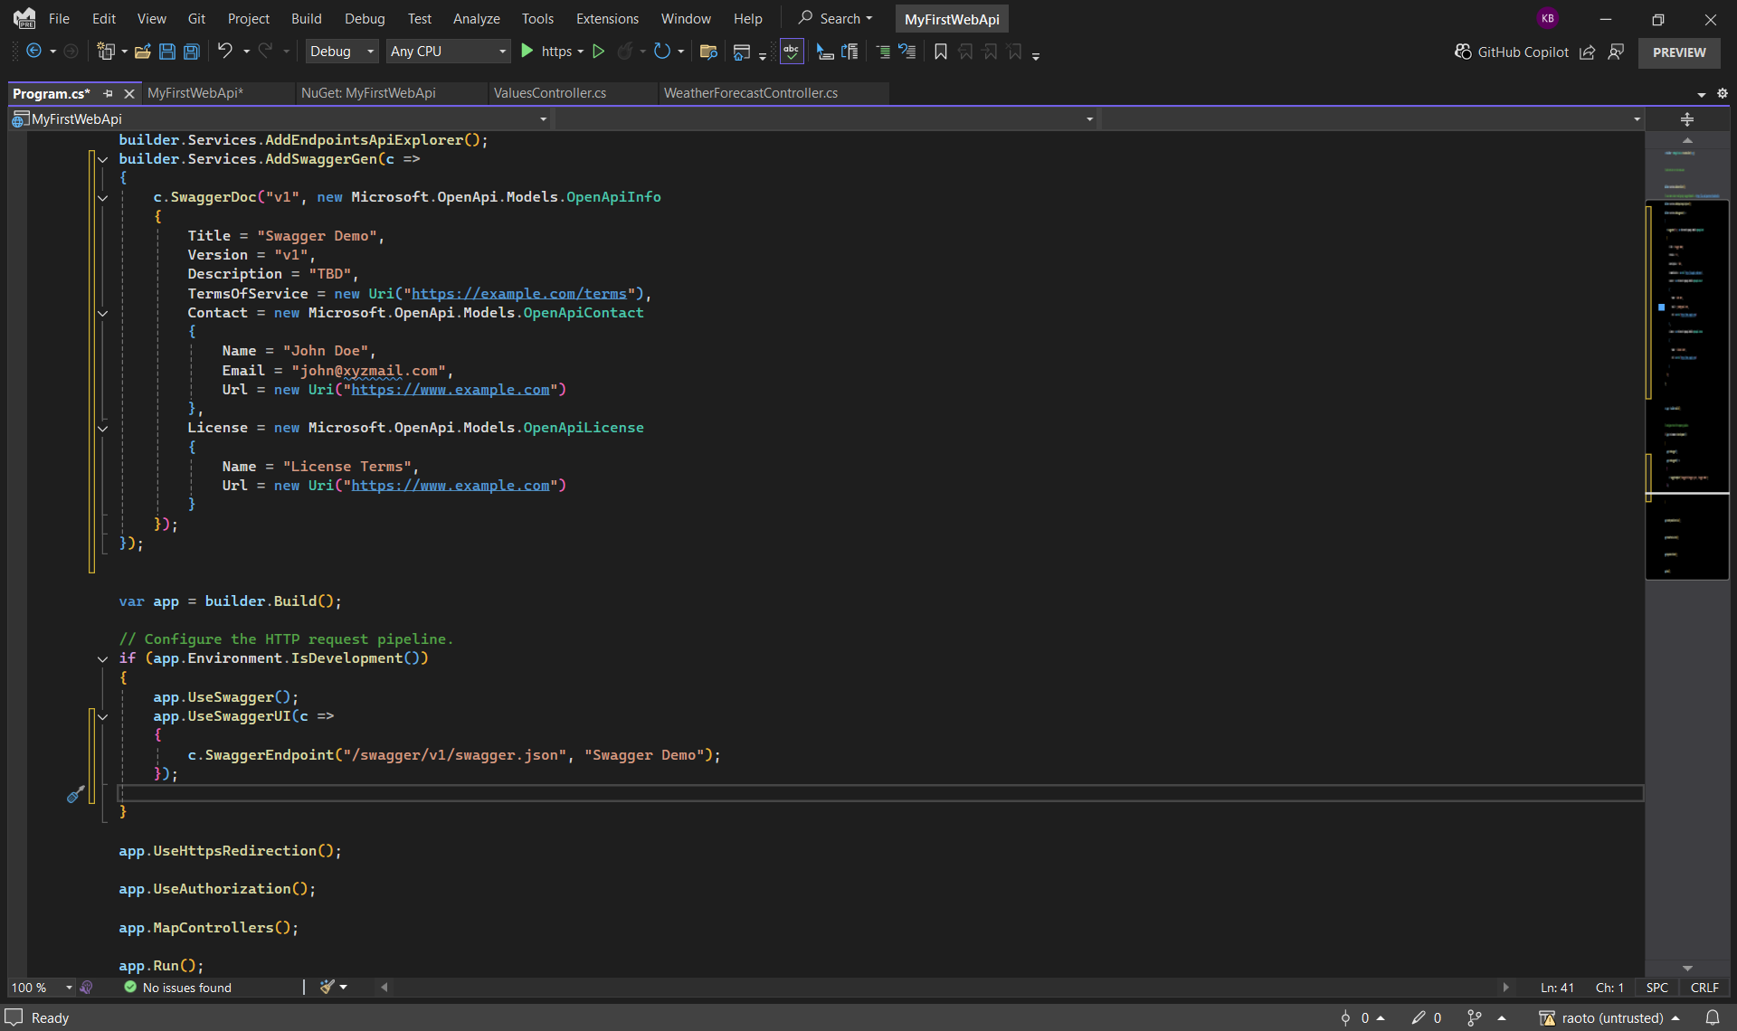

**Swagger - GET Method Response**

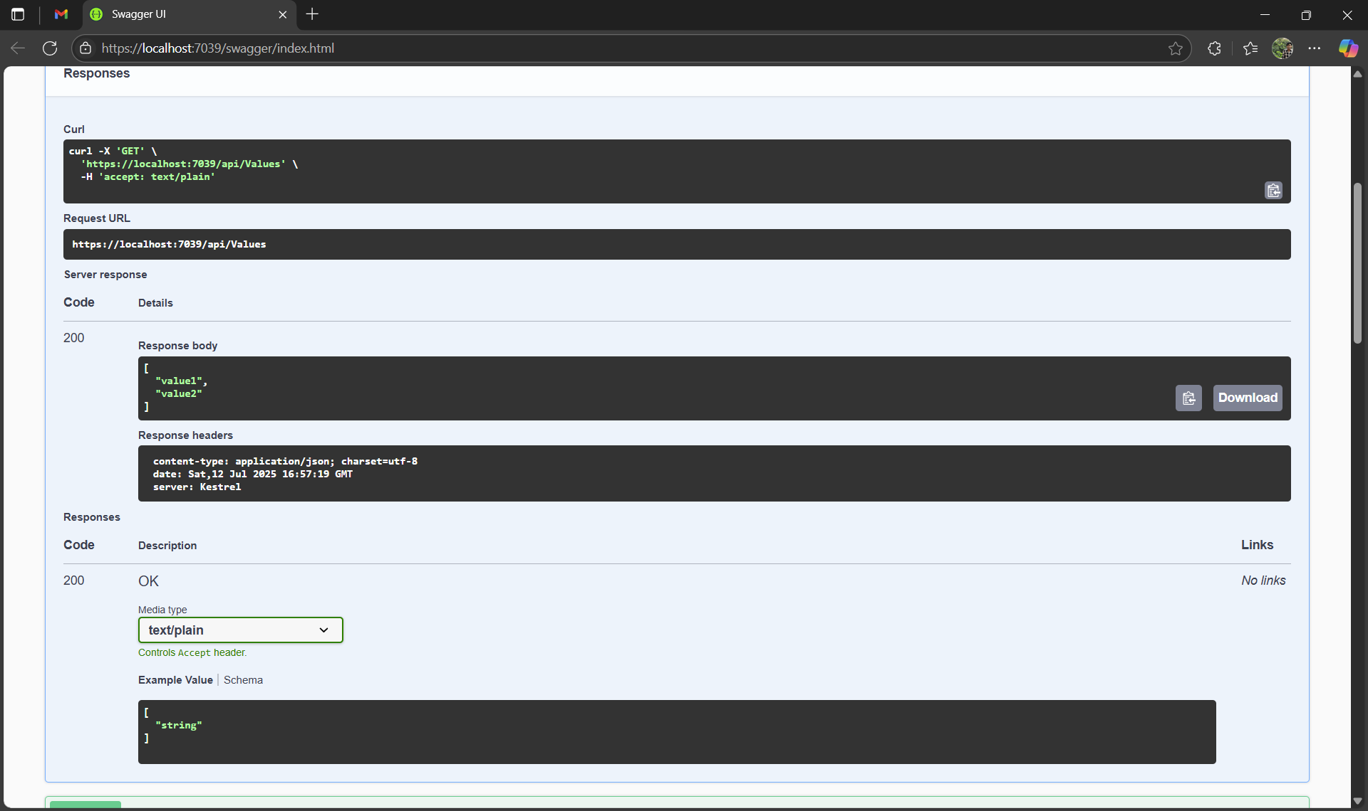

**Swagger UI showing the ValuesController listed**

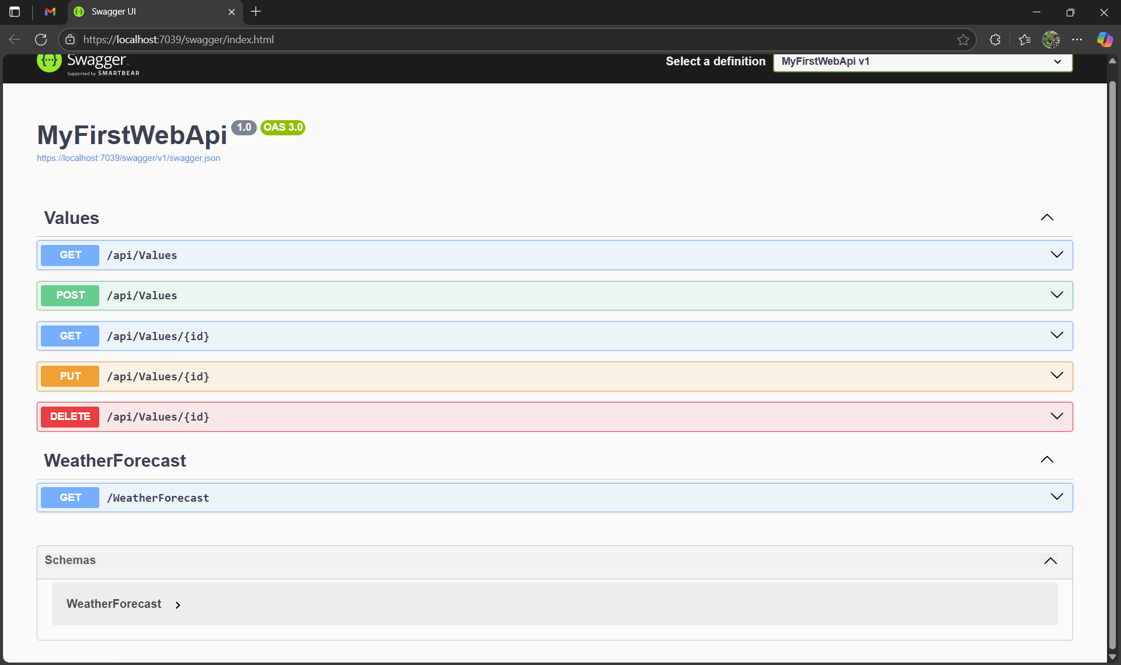

## 

## **Document 2: Testing API with Postman**

Postman - GET Request and Response

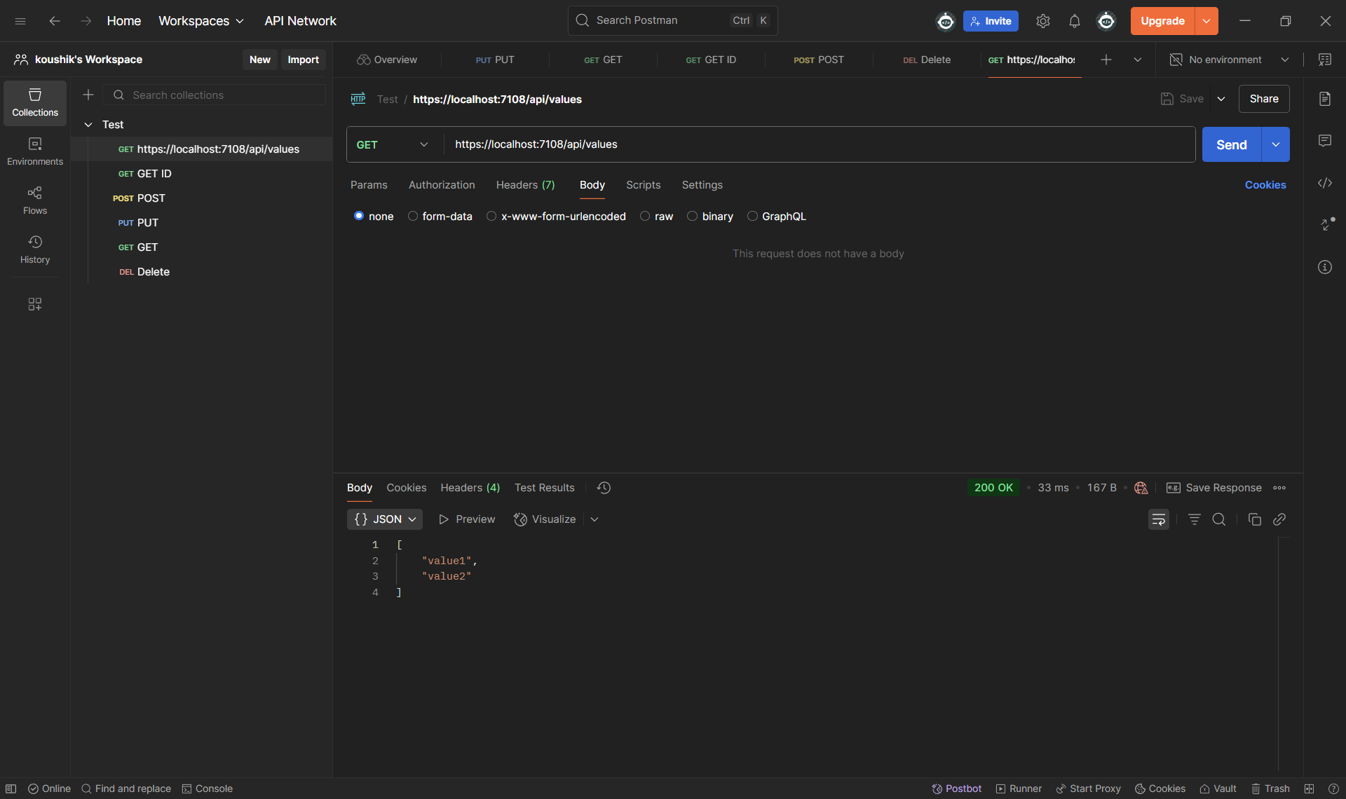

Swagger - POST Request to /api/Values with Response:

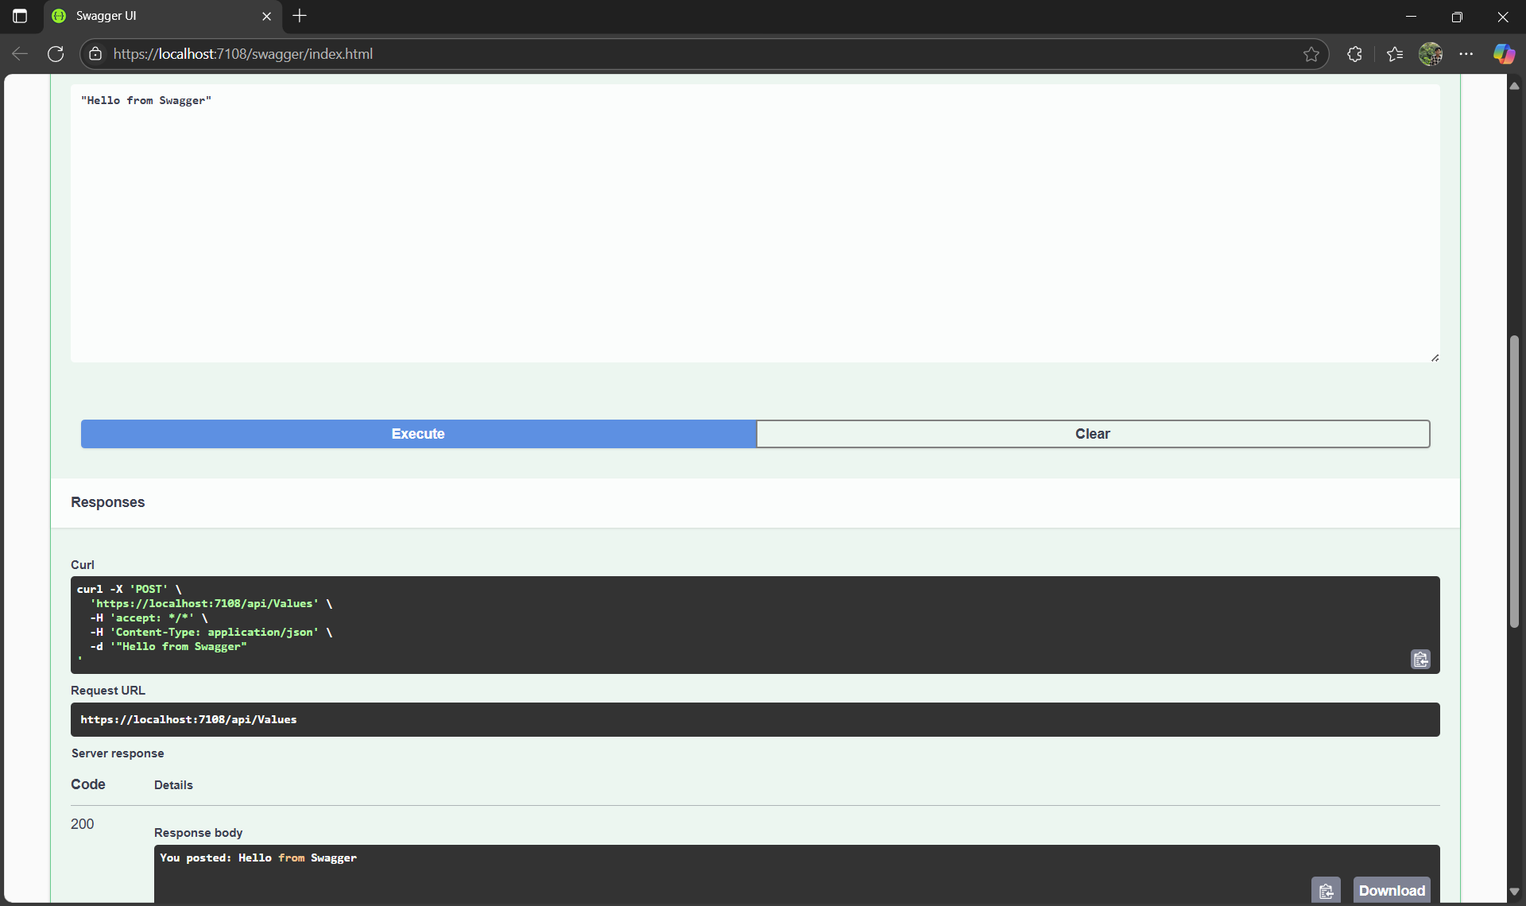

Swagger - GET Request to /api/Values/3:

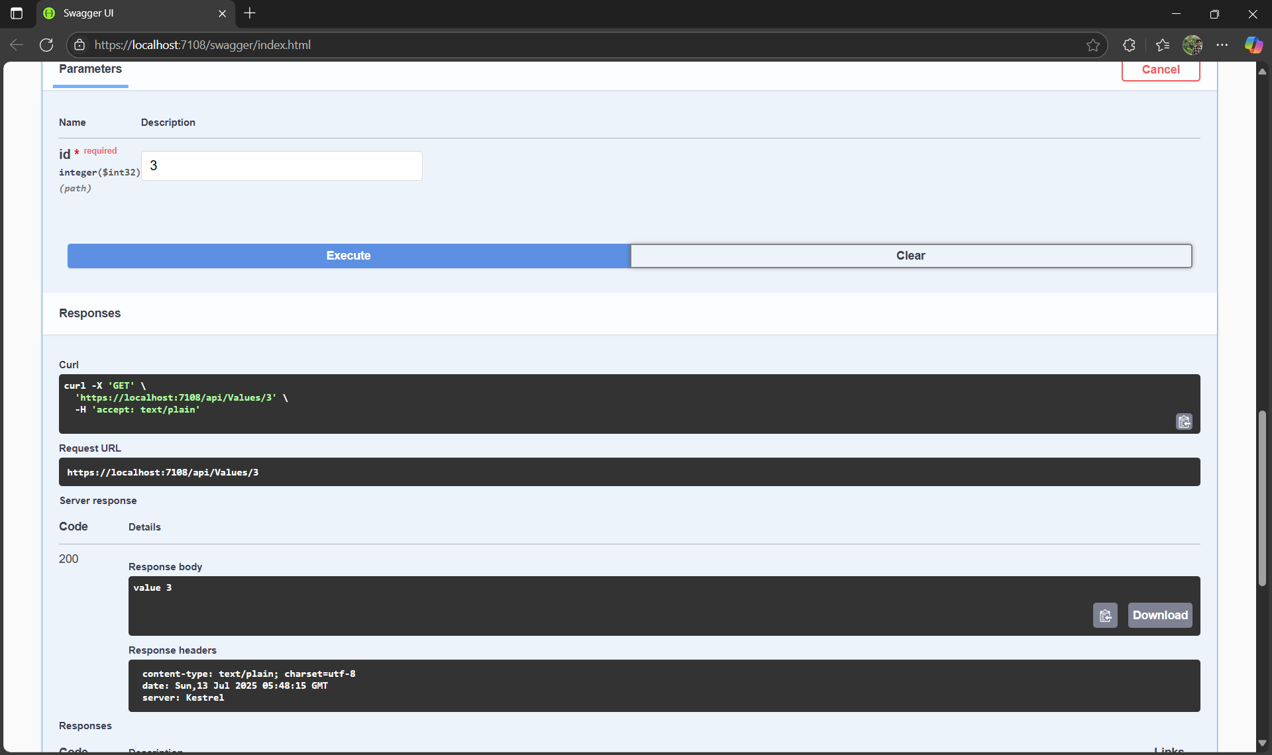

Visual Studio - ValuesController.cs Code with CRUD Methods:

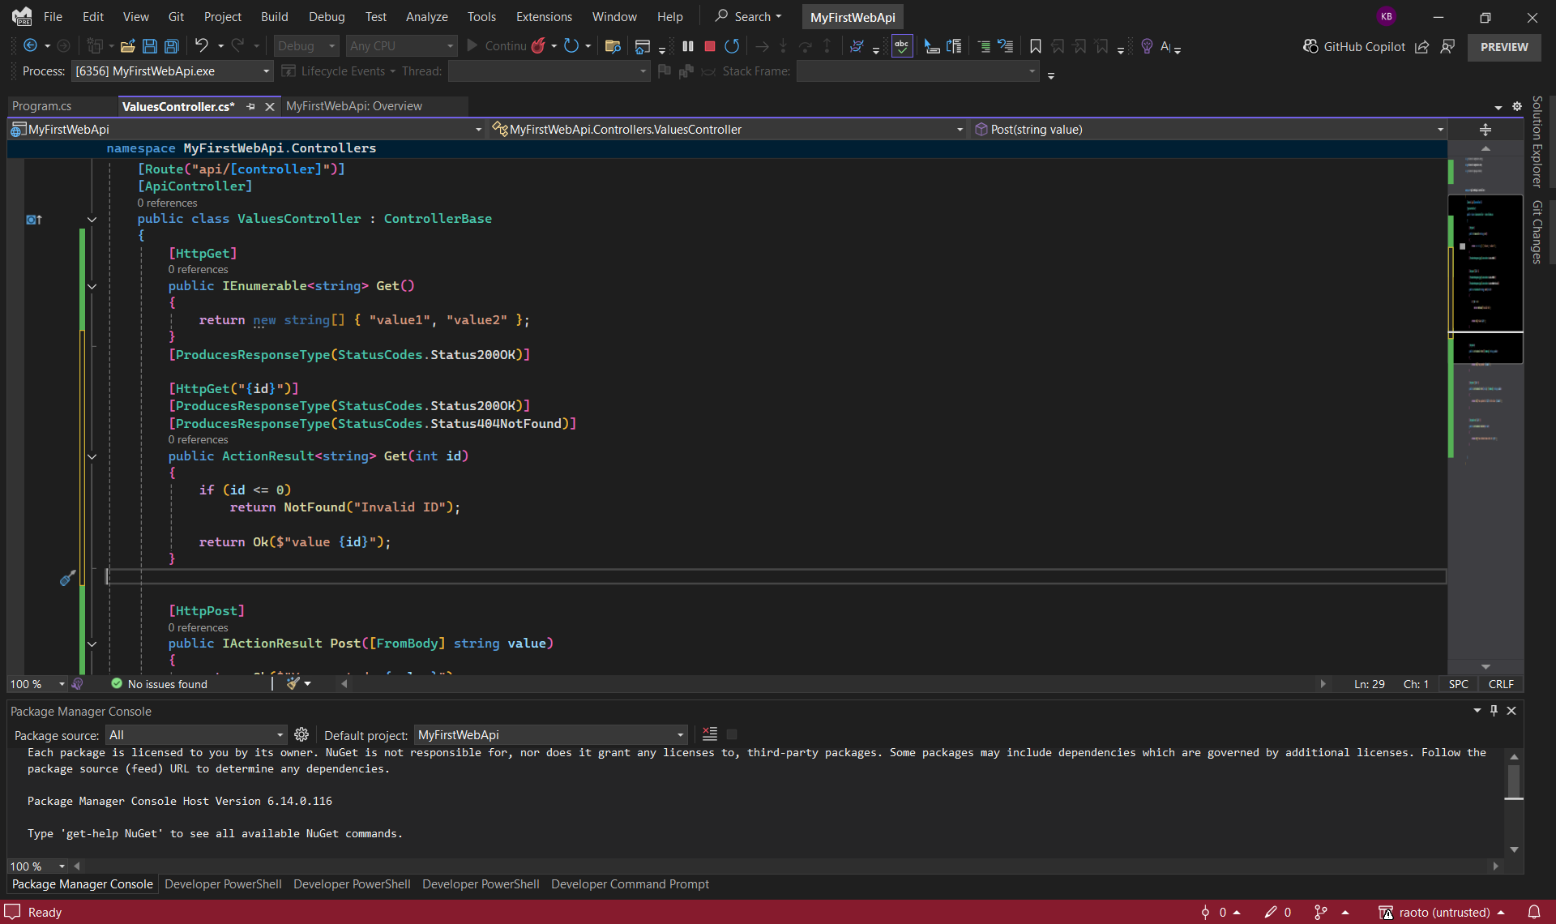

## Document 3: Action Filter and Exception Handling

Created a class named Employee.cs with properties:

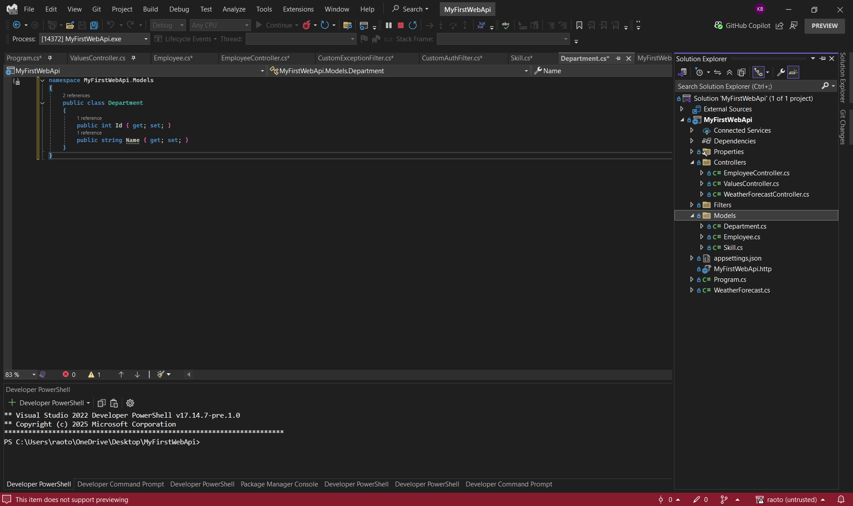

## Swagger - GET /api/Employee Showing Employee List:

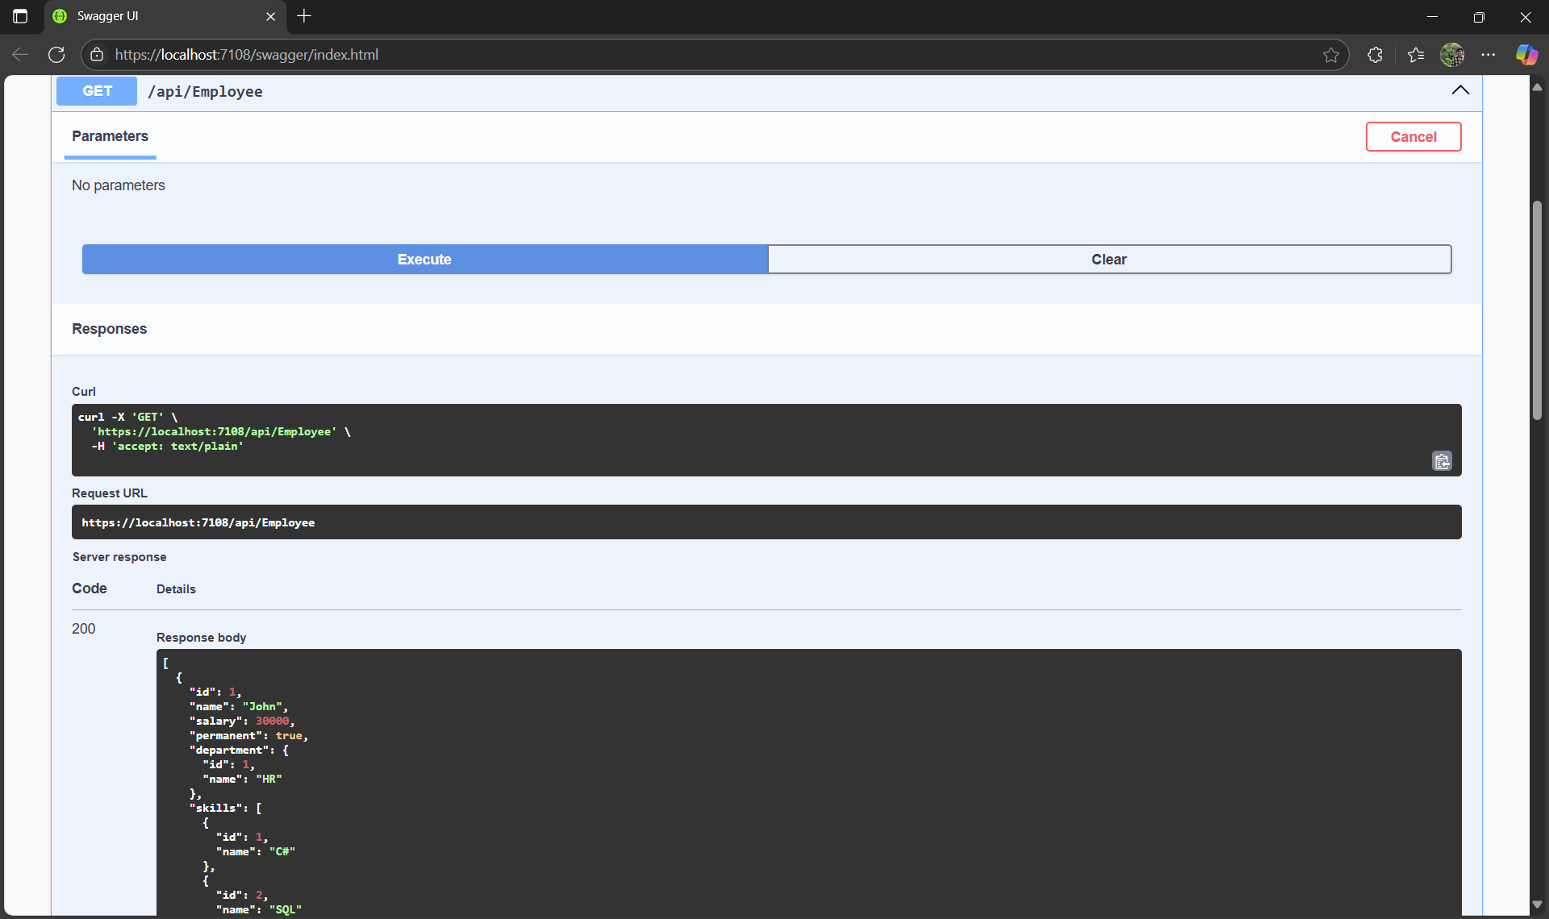

**Swagger - post /api/Employee:**

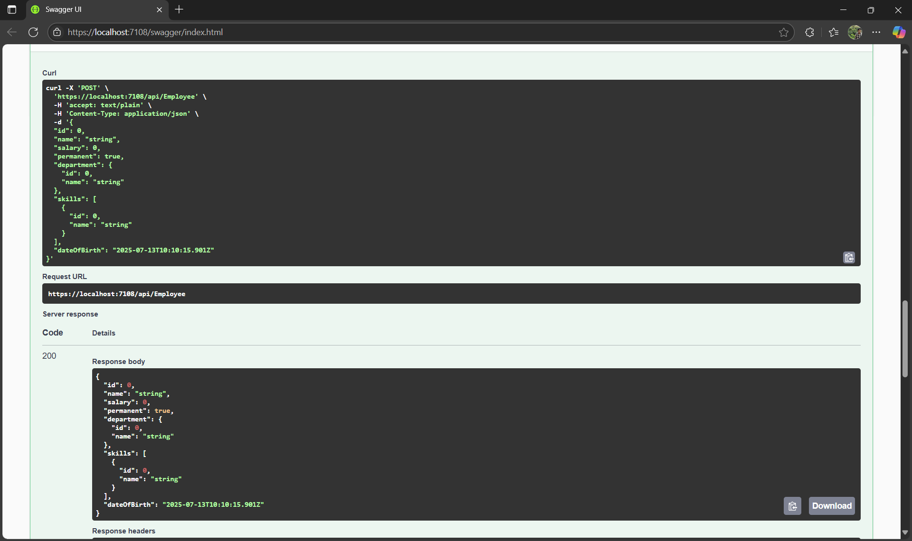

## Swagger - Authorization Header Missing (CustomAuthFilter):

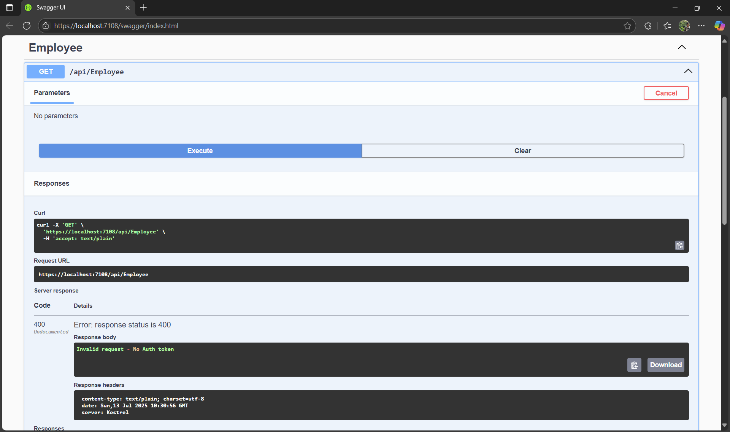

## Postman - GET /api/Employee Returning List of Employee Names:

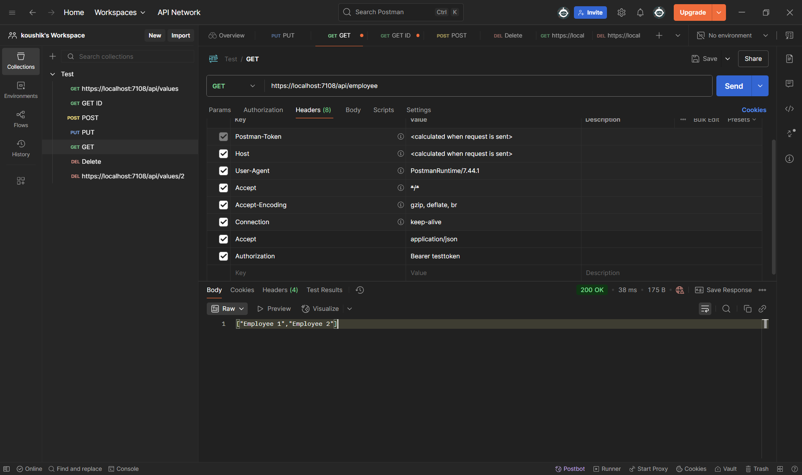

## Visual Studio - CustomAuthFilter.cs Code Implementation:

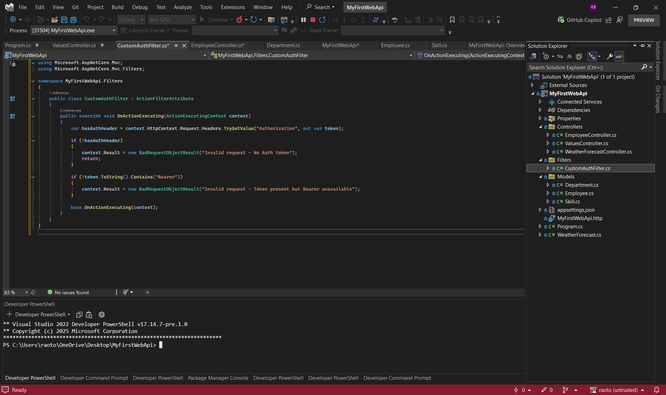

## Document 4: Web API CRUD Operation – Put and Delete

Swagger UI - CRUD Endpoints for Employee and Values Controllers (GET, POST, PUT, DELETE)

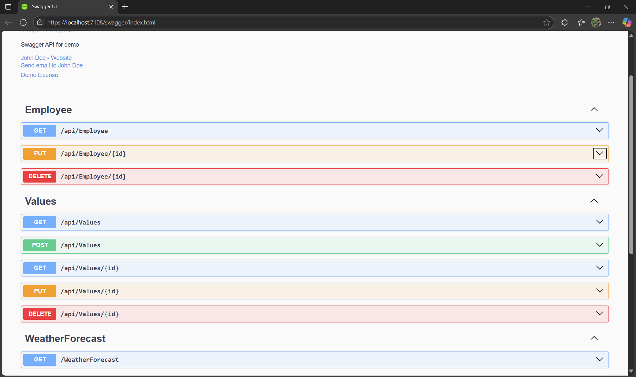

Swagger - PUT Employee with Valid ID (200 OK)

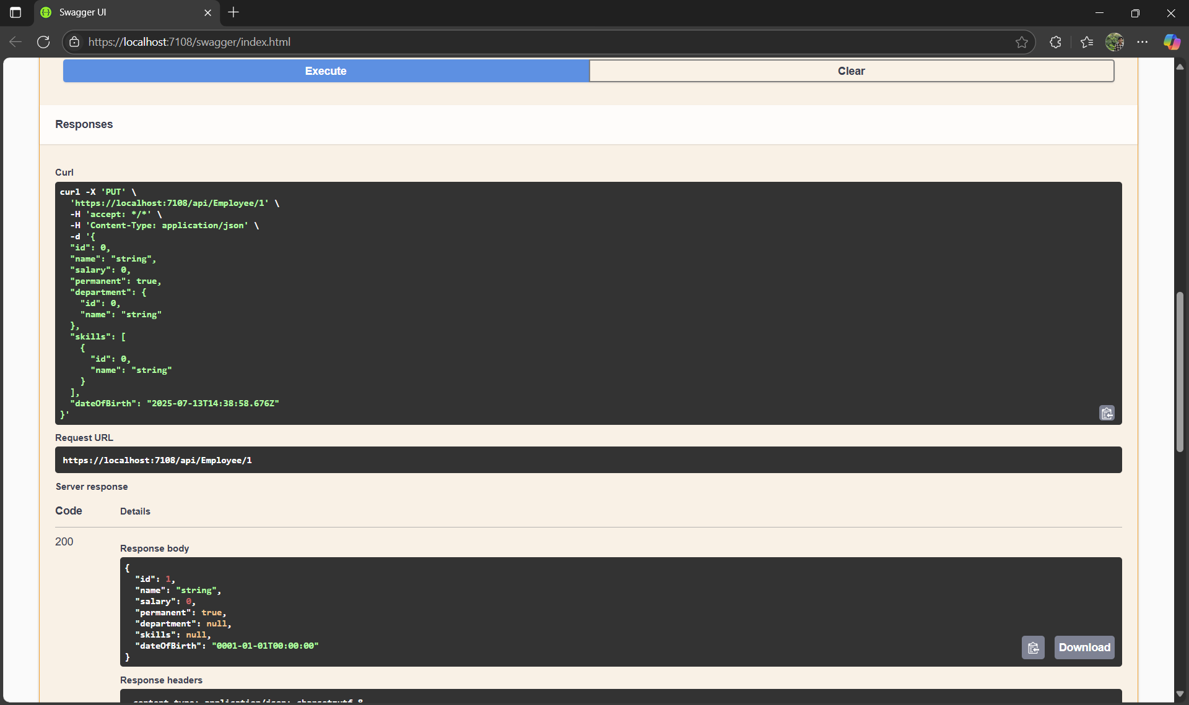

Swagger - PUT Employee with Invalid ID (400 BadRequest):

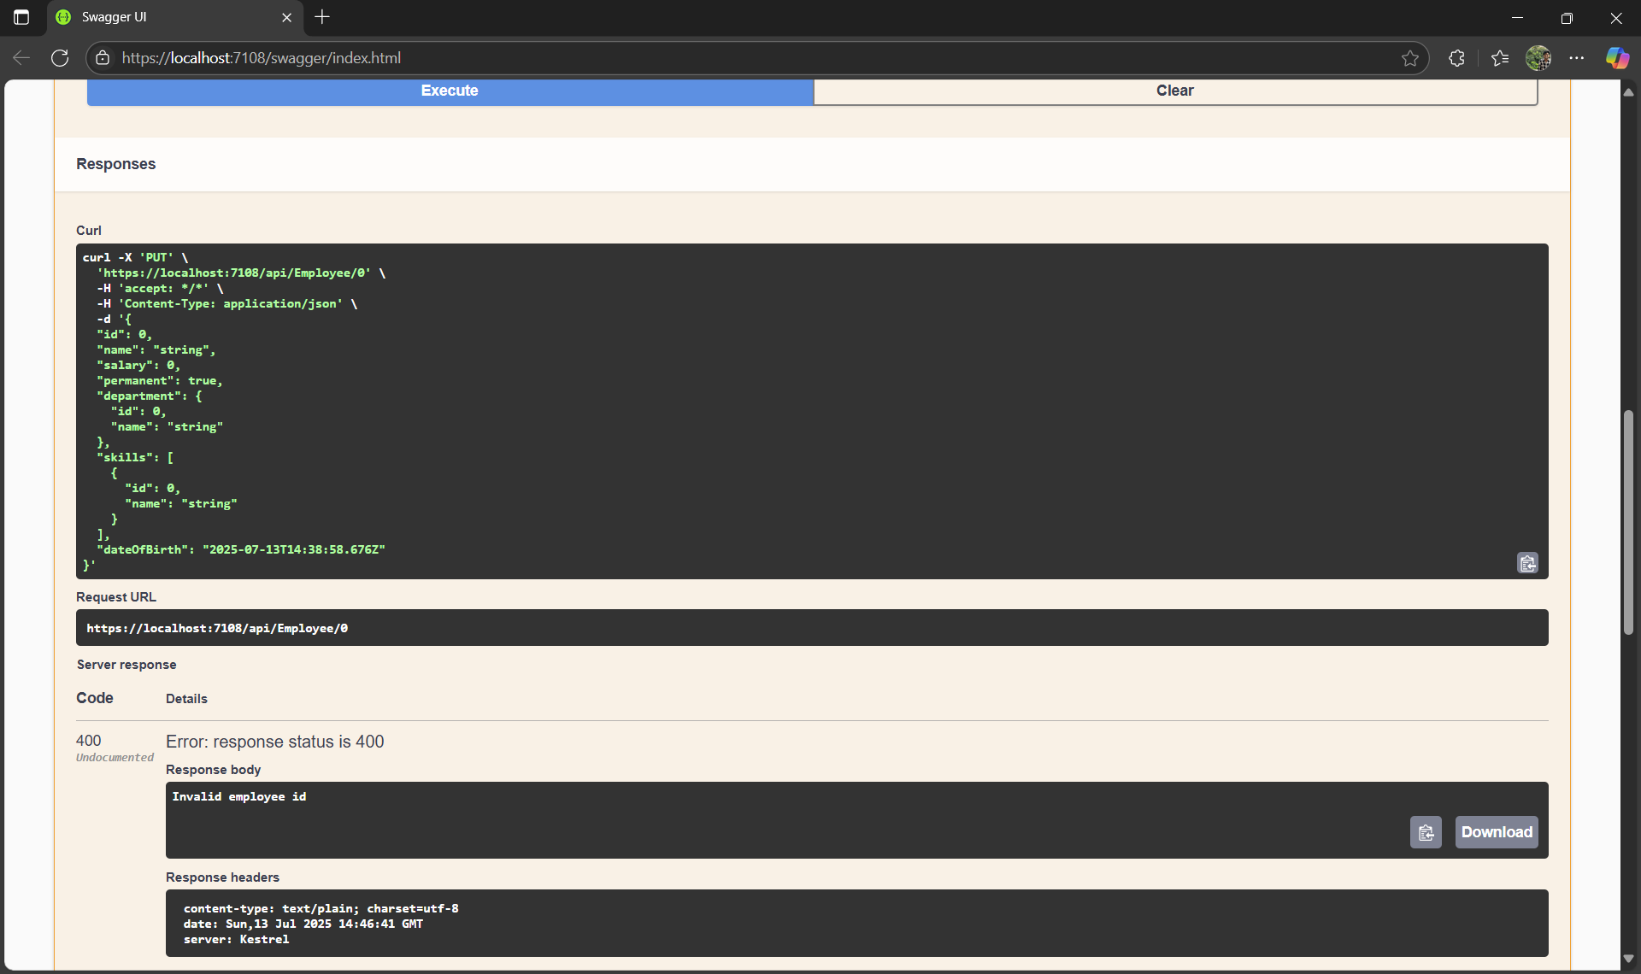

Swagger - GET /api/Employee Showing Updated List:

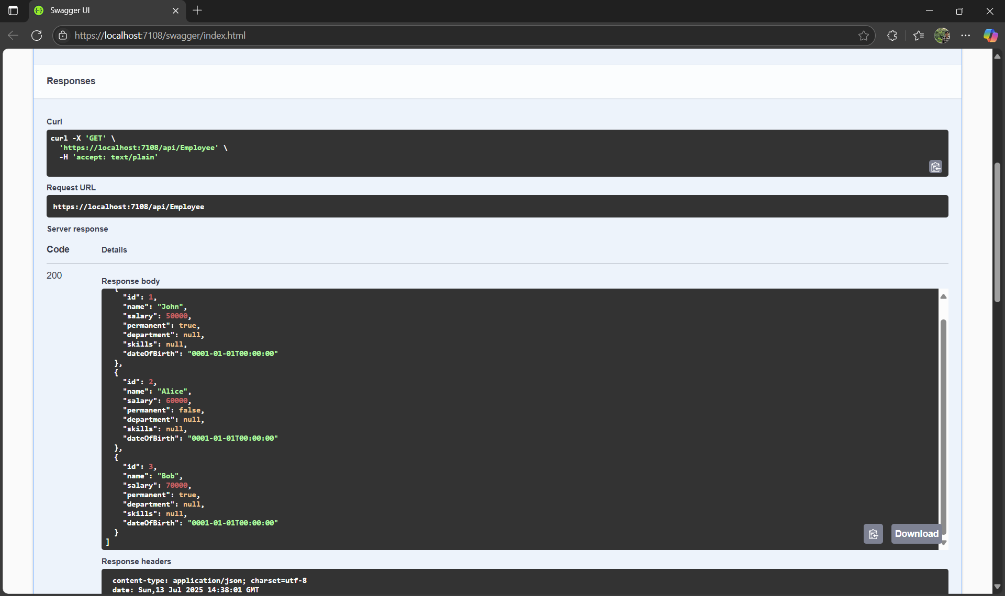

Postman - PUT Employee with Valid ID (200 OK)

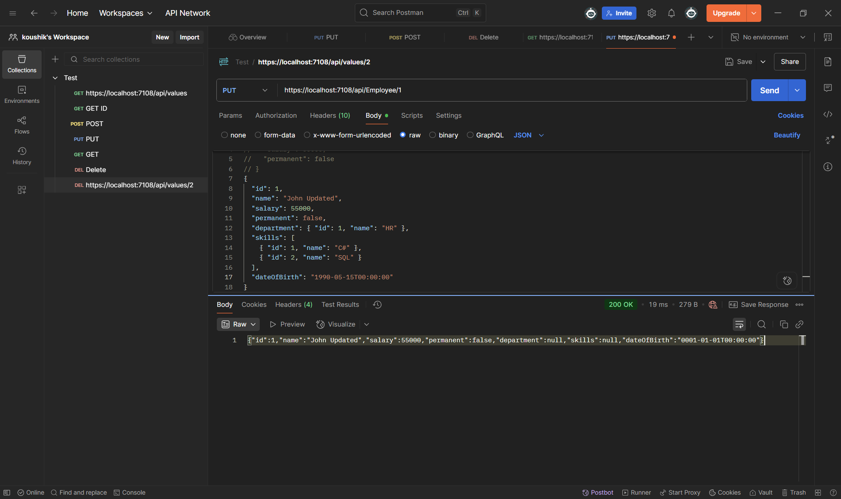

## Document 5: Securing API using JWT Token

## NuGet Package Installation for JWT Authentication :

## C:\week3\week 4\doc5.png

AuthController Implementation for JWT Token Generation:

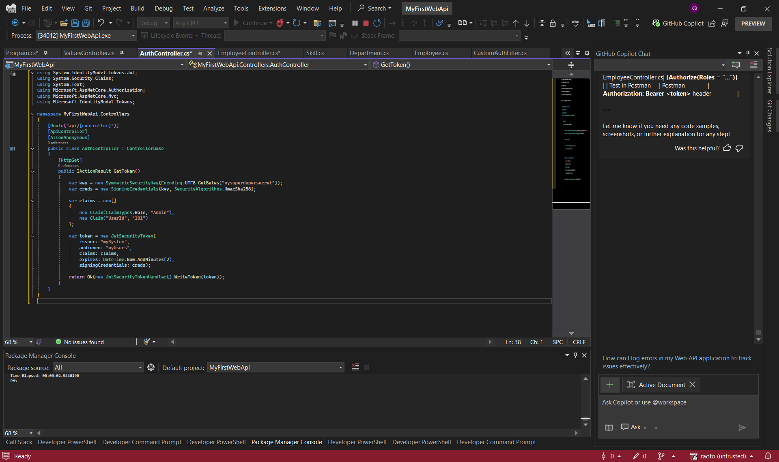

Securing API with Authorize Attribute:

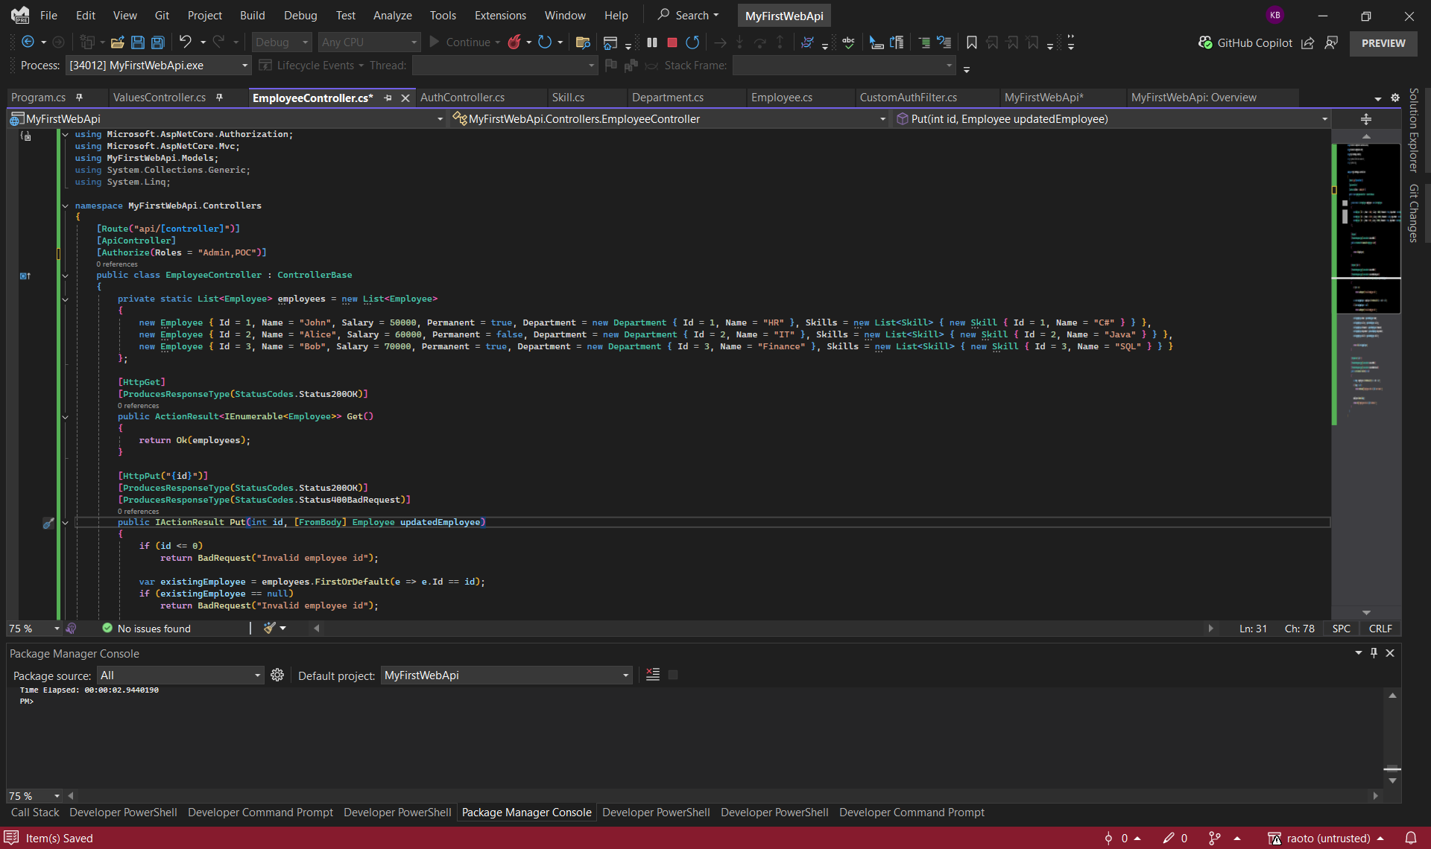

Executing PUT /api/Employee with JWT Bearer Token:

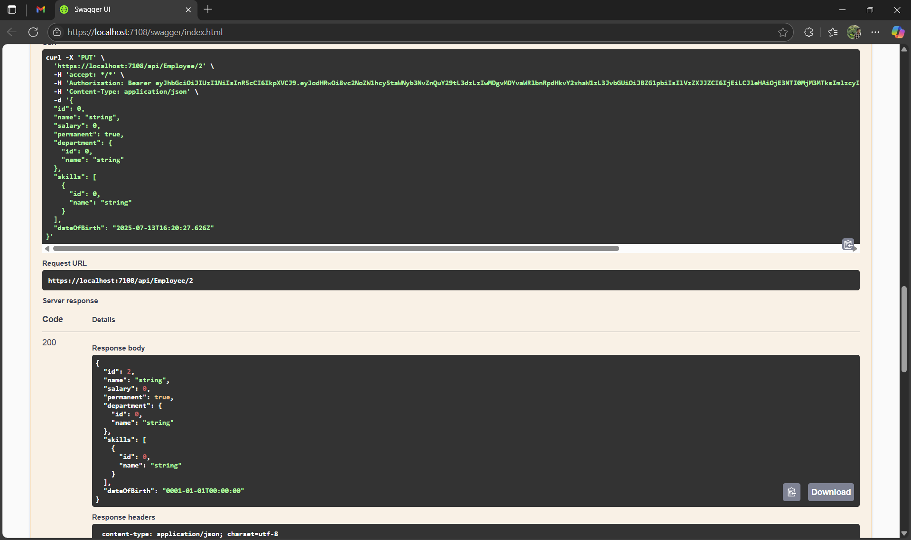

Executing GET /api/Employee/{id} with JWT Token:

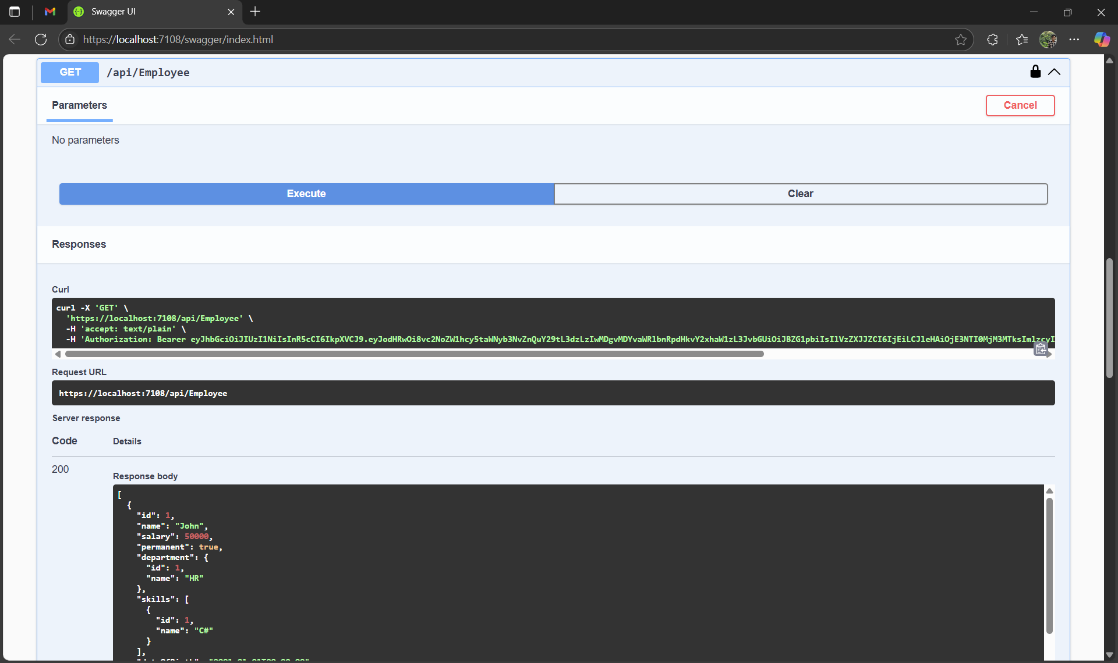

## Document 6: Kafka Integration with C# Chat App

Docker Desktop Showing Zookeeper and Kafka Containers Running:

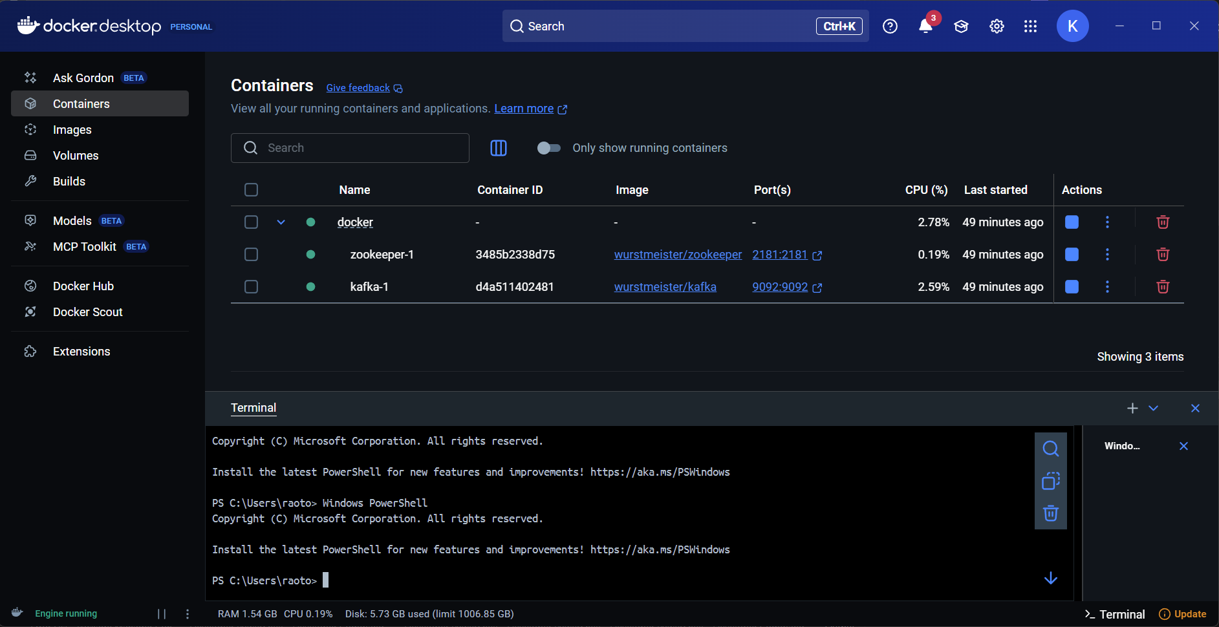

Kafka Chat Console Producer - Sending Messages:

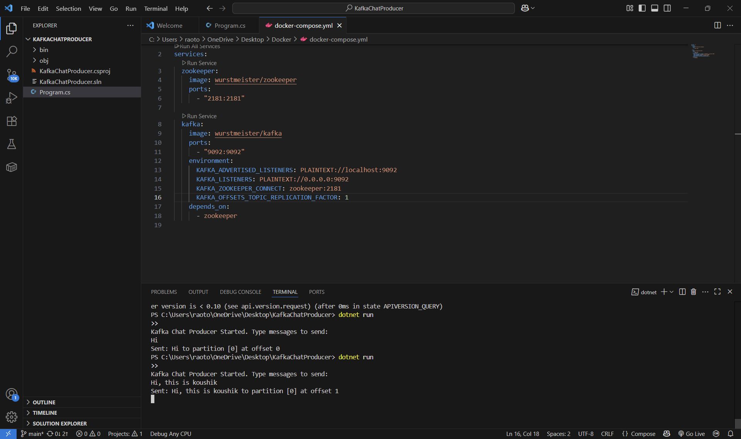

Kafka Console or WinForms Consumer Receiving Messages:

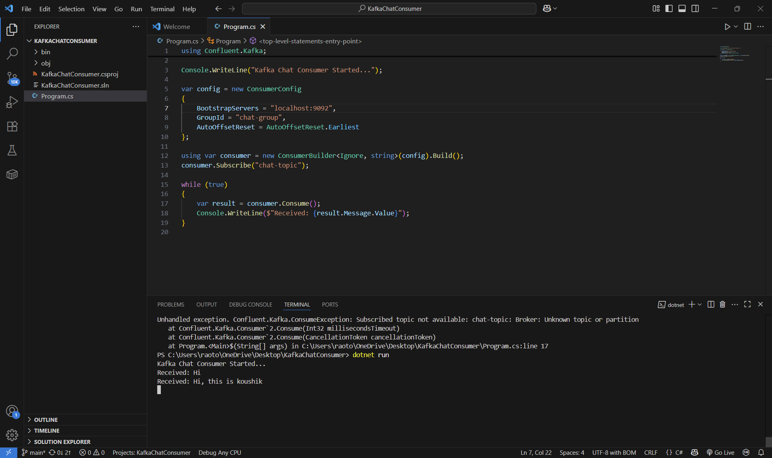

Command Prompt Running Kafka Server Logs:

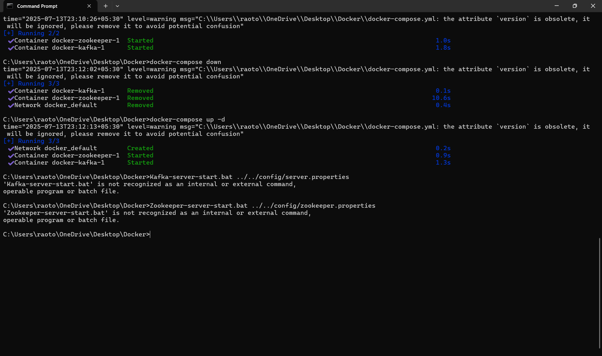

Two Windows Forms Chat Clients Communicating via Kafka:

